**Conservational value of Aculeata communities in sand quarries in relation to ecological succession**

## **Abstract**

The sand quarries that are used occasionally and not subjected to rehabilitation, are important biodiversity banks in both anthropogenic and semi-natural landscapes. However, dynamic ecological succession takes place in these environments, which can significantly affect their value for biodiversity preservation. We determined responses of 3 groups of Aculeata to successional transformations in 32 sand quarries, spanning 15 years of spontaneous succession. We focused on groups representing diverse trophic behaviours of their larvae: herbivores (Apiformes), predators (Spheciformes), and kleptoparasites (Chrysididae). These groups differed in their response to successional changes in vegetation. Communities of herbivores and kleptoparasites changed in a similar way and reached the highest complexity at the middle stages of succession. For predators, generally, values of community indices remained stable. Not changes in dominance structure but appearance of new species significantly affected community structure of all the three groups of Aculeata. However, species turnover rate for predators increased at the later stages of succession. This was manifested by rapid accumulation of new and rare species. In contrast, β-diversity of kleptoparasites decreased, and in the case of herbivores remained constant throughout successional stages. Predators were also characterized by a high number of prevalent species, present at all stages of succession. This may suggest their important role in plant-arthropod interactions.Our results show the importance of varied processes of species exchange and provide information about preferences of predatory, herbivorous (pollinating), and parasitic Aculeata, including rare and threatened species, in respect of stages of ecological succession in sand quarries. The collected information will allow more deliberate selection of protective measures through implementation of suitable methods of management, to facilitate the preservation of these valuable habitats.

**Keywords:** Apiformes; Chrysididae; Sand quarry; Species turnover; Spheciformes, Succession

**1. Introduction**

Abandoned sand quarries, gravel pits, etc. are colonized by many groups of species, including some threatened and rare taxa in many regions (Tropek et al., 2010; Heneberg et al., 2013, 2016; Twerd et al., 2019a). Hence many publications provide evidence for the high conservation value of post-mining sites as habitats for many orders of arachnids (Tropek and Konvicka, 2008; Tropek et al., 2010) and insects (Brändle et al., 2000; Lenda et al., 2012; Lönnberg and Jonsell, 2012; Tichanek and Tropek, 2015; Harabiš, 2016; de Smedt and van de Poel, 2017), including bees and other aculeates (Krauss et al., 2009; Seitz et al., 2019; Twerd et al., 2019a, 2019b). It was pointed out that insect communities on post-minig sites present high conservation value, but will undergo a spontaneous ecological succession which affects species richness and abundance. However, often no attention is paid to the fact that changes in percentage contributions of individual insect species, caused by plant succession, can **markedly** influence their conservational value.

Temporal variability of insect communities during succession is, along with their abundance and species diversity, an important criterion of ecosystem value. In general, species richness and diversity of insect communities is expected to increase with time, but responses of individual species are often highly specific. In contrast, the dynamics of trophic groups (e.g. herbivores, predators, and parasites) can show more predictive patterns (Siemann et al., 1999) and are of high importance from the standpoint of the whole ecosystem (Christensen, 1995). For example, in the case of pollinators,habitat age has no effect on species abundance and diversity in abandoned fields (Krauss et al., 2009), but it may not be so for other trophic groups, e.g. predators, which depend strongly on the structural complexity of the ecosystem. In general, the proportion of herbivores in the community may decrease in favour of increasingly diverse and abundant predators and parasites (Corbet, 1995; Siemann et al., 1999).

Hymenopterans in sand quarries do not necessarily follow the general predictions of classic successional theories advocating a continuous increase in diversity and abundance (Odum, 1969; Brown, 1984). According to general predictions, the abundance and diversity of aculeate Hymenoptera should increase with time, and there might be fewer rare species at the initial stages of succession (Gathmann et al., 1994; Corbet, 1995). However, bees and wasps are good ecological indicators (Odanaka and Rehan, 2019), and thus their communities dynamically respond to even small changes in their environment. This is due to their high nesting and food requirements (Müller et al., 2006; Ricketts et al., 2008), resulting in a strong relationship with available floral resources (Alanen et al., 2011). Therefore, contrary to the above predictions, early successional stages of abandoned fields were found to harbour diverse Hymenoptera communities because of a high abundance of annual plants (Parrish and Bazzaz, 1979; Alanen et al., 2011; Tscharntke et al., 2011; Roberts et al., 2017). This affects also rare species, which can aggregate in the community thanks to a large variability of microhabitats (Tropek et al., 2010). Numbers of hymenopteran pollinator species (including rare ones) generally decrease with increasing density of plant cover (Rutgers-Kelly and Richards, 2013; Hendrychová and Bogusch, 2016). This is thought to be mainly driven by changes in vegetation characteristics, like species richness or pollination strategies (Gathmann et al., 1994; Losapio et al., 2016). However, recent observations showed that responses of specialized oligolectic bees to successional processes may be more complex (Twerd et al., 2019a). On the other hand, late successional stages are predicted to harbor more diverse parasite and predator communities (Losapio et al., 2016), which can boost numbers of rare species in older quarries.

Important aspects of community change may be missed when focusing only on species numbers, in particular raw numbers of rare species. Conservational value will generally change in the course of succession. However, temporal changes in abundance of some persistent species may reflect their important ecosystem value (Harvey et al., 2017), and rare species may contribute little to functional diversity within ecosystems (Jain et al., 2014, but see Lyons et al., 2005). Therefore, from the conservational standpoint, estimates of shifts in contributions of individual species as well as species turnover rates for different trophic groups in the course of succession in sand quarries are needed.

In this study, we tested a hypothesis that the conservational value of sand quarries, based on aculeate Hymenoptera community, changes due to successional processes. We expected a continuous increase in abundance and species diversity for Aculeata communities. However, we supposed that the detailed patterns would depend on life history of individual trophic groups of aculeates. Herbivores (pollinators) would be the most diverse/abundant at the early and/or middle stages of succession. In contrast, communities of predators and kleptoparasites would change slower, and would accumulate rare species at later stages of succession. We predicted that changes in β-diversity would be caused mainly by the appearance of new species.Species turnover rate would differ between groups presenting diverse trophic behaviours of larvae: decrease for herbivores (pollinators) and increase for parasites and predators. The groups for which the balanced component of β-diversity changes faster would include higher numbers of rare species and of species characteristic of individual stages of plant succession. In contrast, fewer species would be characterized with continuous changes in abundance in the course of succession.

# 2. Material and methods

# *2.1. Study sites*

# Field research was conducted in the Podlasie region (NE Poland), in the immediate vicinity of extensive woodlands of Białowieża Forest and Knyszyn Forest. This area is rich in natural deposits of sand and gravel, which result mostly from glacial and fluvioglacial, or rarely fluvial accumulation (Siliwończuk, 1985). As much as 69% of the deposits have never been exploited or their extraction was stopped, while the other 31% are exploited permanently or periodically.

This study was conducted in 32 periodically exploited or abandoned sand quarries (Table A1, Fig. 1), which are subject to spontaneous succession. The investigated sites varied in stages of ecological succession and were covered mostly with synanthropic herbaceous vegetation. Synanthropic plant species included e.g. *Anchusa officinalis* L., *Ballota nigra* L., *Daucus carota* L., *Echium vulgare* L., *Lamium purpureum* L., and *Leonurus cardiac* L*.* The dominant grass species in those habitats were *Calamagrostis epigejos* (L.) Roth, *Elymus repens* (L.) Gould and *Poa pratensis* L., while among woody species, *Pinus sylvestris* L. was the most abundant.

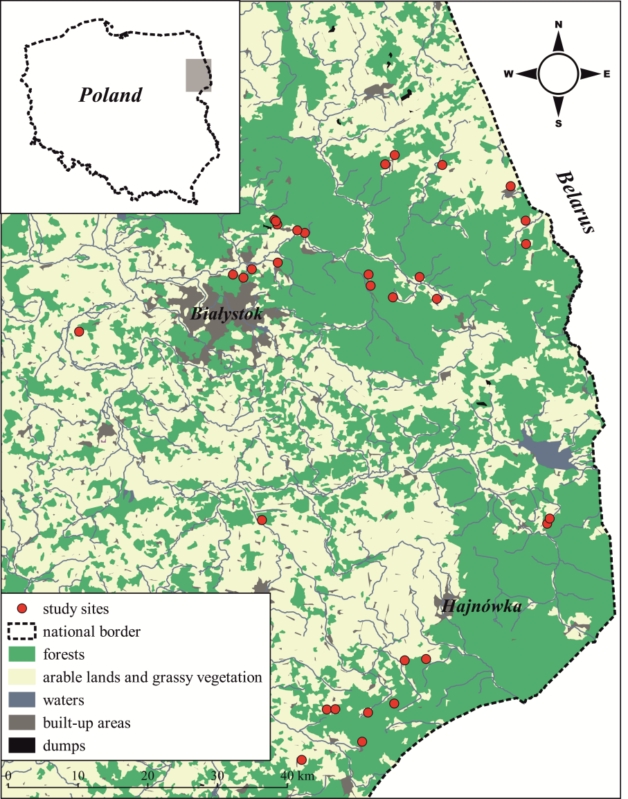

**Fig. 1.** Location of study sites (sand quarries).

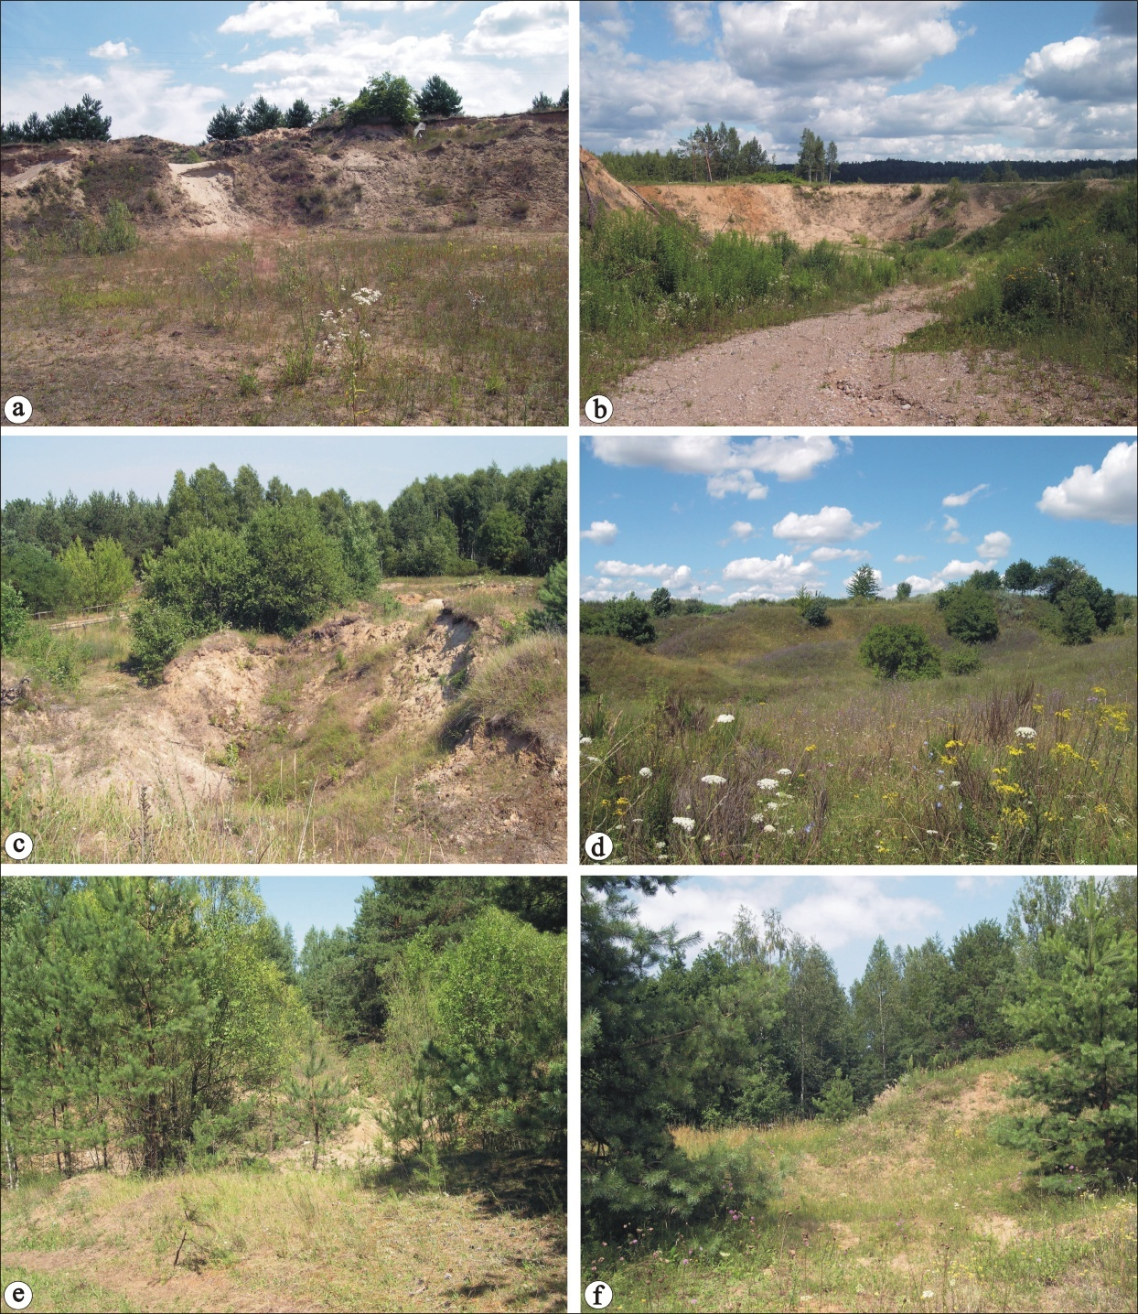

**Fig. 2.** Representative photographs of stages of plant succession in sand quarries: a, b = early succession; c, d = middle succession; e, f = late succession.

The analysed sand quarries were divided into three groups, depending on the stage of plant succession, namely stage I: 0–5 years, i.e. early succession (initial colonization by plants – 10 sand quarries): bare soil ≥ 55% of the area, herbaceous vegetation 20–45% of the area; stage II: 5–10 years, i.e. middle succession (sward formation – 12 sand quarries): bare soil ≤ 45% of the area, herbaceous vegetation 35-80% of the area, woody vegetation ≥ 5%; stage III: 10–15 years, i.e. late succession (development of woody vegetation – 10 sand quarries): bare soil ≤ 5% of the area, herbaceous vegetation 15–40% of the area, woody vegetation ≥ 60%. Percentage contributions were estimated in relation to the total area of the sand quarry (Table A1).

This study is a continuation of a project concerning the importance of sand quarries for wild bees, which was initiated in 2015. The material used here was collected in 2008, 2015–2016 (Twerd et al., 2019a, 17 sites), and in 2017 (15 sites). Research was conducted after obtaining oral consent from managers of the land and in accordance with applicable law.

*2.2. Insect sampling*

The insects were collected when the weather was favourable for Aculeata activity, i.e., with no or little wind (< 3 on the Beaufort scale) (Krauss et al., 2009). During field research, the temperature was always above 16°C, and on most days it did not exceed 25°C. Due to the fact that the phenological periods in Eastern Poland are delayed in relation to the central part of the country by about two weeks, the research was conducted in May and July, in order to obtain the fullest possible number of both spring and summer species. In each sand quarry, the insects were caught along transects. Each transect was 200 m long and 1 m wide (Banaszak, 1980). Each researcher surveyed one transect for 30 minutes and collected the selected group of Aculeata (Apiformes, Crabronidae and Sphecidae, Chrysididae). The transects were visited in a random order throughout the season, to cover the entire period of Aculeata activity during the day. The number of delimited transects was adjusted to the size of sand quarries, in 3 categories: 0.5–1.0 ha (no more than 4 transects), 1.0–3.0 ha (no more than 8 transects), > 3.0 ha (no more than 12 transects). One sample was a collection of insects caught during one day in one sand quarry. Information about numbers of surveyed transects, depending on site area, is presented in Table A1. To avoid self-replication, the sampled quarries were spaced more than 1.5 km apart. The collected specimens were pinned and identified to the species level. Species of the *Bombus lucorum* complex (Bossert, 2015) are not distinguishable by morphological features, so *B*. *lucorum* and *B*. *terrestris* are easily confused (Wolf *et al.*, 2010); therefore, data on the occurrence of bumblebees of the subgenus *Bombus* Latreille, 1802 = *Terrestribombus* Vogt, 1911 were pooled. Species names followed Bitsch and Leclercq (1993), Skibińska (2004), Jacobs 2007, Wiśniowski (2015), and Kuhlmann et al*.* (2020) (Table A2). We identified the status of threatened bee and wasp species according to the most recent editions of the Polish Red Lists provided by Banaszak (2004), Celary (2004), Skibińska (2004), and Wiśniowski (2015).

The Aculeata were divided into 3 groups representing diverse trophic behaviours of larvae (= life histories): herbivores (Apiformes), kleptoparasites (Apiformes, Chrysididae, Crabronidae) and predators (Crabronidae and Sphecidae).The group of herbivores was composed of bees, i.e. aculeates completely biologically linked with flower forage: imagines feed mostly on nectar, while larvae are fed with nectar and pollen. However, numerous bee species have adopted a kleptoparasitic way of life (Michener, 2007). Predators were represented by species of the families Crabronidae and Sphecidae. The majority of females of digger wasps hunt for insects or spiders as food for larvae, but there are some *Nysson* species (Crabronidae) that have lost their hunting instinct, becoming specialized in entering the nests of other species and laying their eggs on their host victims (Bohart and Menke, 1976). Adult digger wasps feed mainly on nectar and aphid secretions, sometimes on their hosts (Olszewski and Kowalczyk, 2019). Cuckoo wasps (Chrysididae) are a group of wasps that develop during the larval stage as kleptoparasites or parasitoids of mainly other hymenopterans (Paukkunen et al., 2015).

*2.3. Statistical analysis*

All the analyses were performed in the R statistical environment (R Core Team, 2019). We used generalized linear models (GLMs) to assess differences in species diversity, species richness, and abundance of the communities. Error distribution for abundance was investigated with the use of a negative binomial model, in MASS package (Venables and Ripley, 2002), while for species number, with the use of the Poisson distribution. To study interactions between individual groups of aculeates at individual stages of succession, we conducted a post-hoc test with Tukey correction for multiplicity in emmeans package (Lenth, 2019).

To verify if plant succession was responsible for changes in community structure we performed redundancy analysis (RDA) with successional stage as an explanatory variable,. Before the analysis, the matrix of abundance was subjected to the Hellinger transformation (Legendre and Cáceres, 2013). To identify the species most strongly reacting to the stages of succession, we fitted abundance of individual species to the defined RDA model, using envfit function of the vegan package (Oksanen et al., 2019). The number of species with significant vs. non-significant responses in each group were summarized in a 3x2 contingency table. Homogeneity of the contingency table was then tested with likelihood-ratio chi-square statistic (G2). To understand better the underlying relationships between species responses and trophic groups, we further decomposed the above table following the rules of partitioning in Agresti (2012). Partitioning steps can be found in a supplementary R code (https://github.com/szefer-piotr/sand_quarries).

We calculated the rates of species exchange (β-diversity) on the basis of the transformed abundance matrices and assessed the character of changes in community structure between stages of succession for individual groups of the Aculeata. We used the Bray-Curtis (BC) dissimilarity as a measure of β-diversity. According to Baselga (2013), we adopted the subdivision of β-diversity into two components: associated with changes in dominance structure of species (gradient component) and associated with appearance of new species (balanced component). We calculated both components for all the possible pairs of sites at stages I and II as well as II and III. For comparisons of two successional stages, a site from an earlier stage was used as a random factor to account for local differences in community composition. For statistical analysis, we adopted an additional assumption concerning the permissible values of β-diversity, i.e. that no comparison between stages can be completely different (BC = 1) or completely identical (BC = 0), so empirical values of β-diversity equal to 0 or 1 were replaced by 0.001 and 0.999, respectively. This allowed us to use the beta distribution in the statistical analysis. Statistical significance of changes in mean components of β-diversity for stages of succession and individual groups of species were calculated using the *glmmTMB* package (Brooks et al., 2017). Components of β-diversity were calculated using the *codyn* package (Hallett et al. 2019).

To determine the strength of association of species with successional stage, we calculated indicator values (IndVal) of Aculeata species recorded there (Dufrêne and Legendre, 1997). The significance of IndVals was confirmed by a Monte Carlo test with 9999 permutations. We summarized the results in a 3x3 contingency table for three successional stages and three trophic groups. As above, we used the G2 statistic to test for homogeneity and individual partitioning steps can be found in a supplementary R code.

To calculate the probability that an individual belongs to any category of vulnerability for each trophic group at all three stages, we used binomial distribution with a logit link function. Like above, the post-hoc Tukey test was used to assess statistical significance.

**3. Results**

*3*.*1*. *Wasp and bee species composition*

In total, 8230 individuals of 272 species of Aculeata were recorded. In respect of species richness, 51.47% (140 species) were herbivores, 25.37% (69 species) were predators, and 23.16% (63 species) were kleptoparasites. Expected species richness (Chao 1 estimator) was calculated for groups of Aculeata differing in trophic behaviours of larvae and for Aculeata found at individual stages of succession (Fig. A1 and A2). Simultaneously, 20.22% of the recorded species were threatened or rare (Table A2), and herbivores accounted for 9.93% (19.29% of the group), predators for 4.78% (18.84% of the group), and kleptoparasites for 5.51% (23.81% of the group).

*3*.*2*. *Patterns in community characteristics*

Total species richness (chi square test, *p* < 0.001) and abundance (chi square test, *p* = 0.019) of Aculeata significantly increased with successional changes. In contrast, overall diversity did not change (Table A3). This pattern was primarily due to a significant increase in abundance and species richness in parasites and herbivores at the middle stage of succession (Table 1, Fig. 3). In the case of predators, we did not detect any changes in overall values of community indices. Species richness, abundance, and diversity were usually the highest for herbivores and the lowest for kleptoparasites. At the middle stage of succession, the indicators for kleptoparasites and predators were similar, and at the late stage, the diversity of predators was similar to that of herbivores.

**Table 1.** Mean values and their asymptotic 95% CIs for linear and generalized linear models for diversity (Shannon index), abundance, and species richness of three Aculeata trophic groups at three studied successional stages. Different Latin letters in the last column correspond to statistically significant differences (Tukey correction for multiplicity, ***α*** > 0.05). Successional stages: I = early; II = middle; III = late.

|  |  |  |  |  |  |  |  |  |  |
| --- | --- | --- | --- | --- | --- | --- | --- | --- | --- |
| Index | Stage | Aculeata group | Mean value | Standard error | df | Lower 95% CL | Upper 95% CL | Significance | |
| Diversity (Shannon index) | I | Herbivores | 2.91 | 0.10 | Inf | 2.71 | 3.10 | de | |
| Kleptoparasites | 1.83 | 0.10 | Inf | 1.64 | 2.03 | a | |
| Predators | 2.39 | 0.10 | Inf | 2.19 | 2.59 | bc | |
| II | Herbivores | 3.14 | 0.09 | Inf | 2.96 | 3.33 | e | |
| Kleptoparasites | 2.12 | 0.09 | Inf | 1.94 | 2.30 | ab | |
| Predators | 2.31 | 0.09 | Inf | 2.13 | 2.49 | bc | |
| III | Herbivores | 2.92 | 0.10 | Inf | 2.72 | 3.12 | de | |
| Kleptoparasites | 2.00 | 0.10 | Inf | 1.80 | 2.20 | ab | |
| Predators | 2.65 | 0.10 | Inf | 2.45 | 2.85 | cd | |
| Species richness (Poisson) | I | Herbivores | 3.82 | 1.78 | Inf | 28.50 | 35.52 | e |  |
| Kleptoparasites | 8.42 | 0.92 | Inf | 6.75 | 10.38 | a |  |
| Predators | 17.46 | 1.32 | Inf | 15.03 | 20.29 | cd |  |
| II | Herbivores | 42.95 | 1.89 | Inf | 39.25 | 46.99 | f |  |
| Kleptoparasites | 13.46 | 1.06 | Inf | 11.47 | 15.64 | bc |  |
| Predators | 15.18 | 1.13 | Inf | 13.19 | 17.64 | bcd |  |
| III | Herbivores | 33.12 | 1.82 | Inf | 29.67 | 36.97 | e |  |
| Kleptoparasites | 10.70 | 1.03 | Inf | 8.85 | 12.94 | ab |  |
| Predators | 20.29 | 1.43 | Inf | 17.64 | 23.34 | d |  |
| Abundance (negative binomial) | I | Herbivores | 127.74 | 15.17 | Inf | 100.48 | 160.77 | c |  |
| Kleptoparasites | 17.46 | 2.41 | Inf | 13.33 | 22.87 | a |  |
| Predators | 48.91 | 6.07 | Inf | 38.48 | 62.18 | b |  |
| II | Herbivores | 235.09 | 25.22 | Inf | 190.57 | 290.04 | d |  |
| Kleptoparasites | 51.42 | 5.79 | Inf | 41.26 | 64.07 | b |  |
| Predators | 46.99 | 5.34 | Inf | 37.71 | 58.56 | b |  |
| III | Herbivores | 148.41 | 17.52 | Inf | 116.75 | 186.79 | cd |  |
| Kleptoparasites | 27.11 | 3.55 | Inf | 21.11 | 35.16 | a |  |
| Predators | 54.06 | 6.68 | Inf | 42.52 | 68.72 | b |  |

Inf = infinite; CL = confidence limit

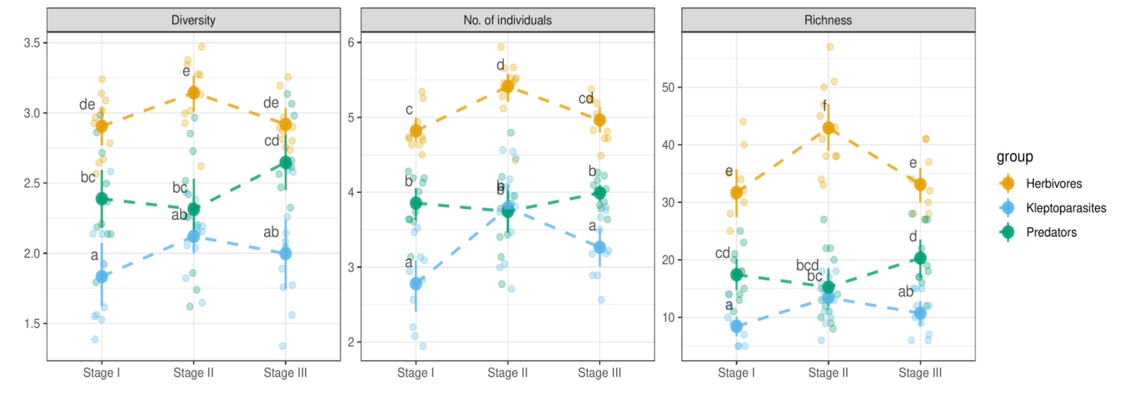

**Fig. 3. Diversity, abundance, and species richness of Aculeata at the three distinguished stages of succession. Abundance was subjected to logarithmic transformation, to visualize better the differences between groups. Transparent points denote empirical values. Latin letters represent** statistical significance at ***α =* 0.05, adjusted for multiplicity (Tukey correction).**

*3*.*3*. *Community structure as a response to successional transformations*

Stages of succession significantly affected the structure of aculeate communities (permutation test, 999 replications, *F* = 2.47, *p* < 0.001), and RDA model explained 14.58% of variation (adjusted *R*-square). Among 272 species of Aculeata, 55 (20.2%) significantly responded to successional transformations. In this group, contributions of herbivores and predators are similar (38.2% and 43.6%, respectively), while kleptoparasites accounted for 18.2%. The species that most strongly reacted to successional transformations are listed in Supplementary Table A4 and Fig. 4. The analysis of 272 species, summarised in a 3x2 contingency table, revealed significant relationships between the Aculeata group and the number of species significantly responding to the RDA model (*G*2 = 11.223, df = 2, *p* = 0.004). Herbivores and kleptoparasites had similar, low percentage contributions of species significantly reacting to the successional stages (15% and ~16% respectively,*G*2 = 0.025, df = 1, *p* = 0.873). Predatory species had a significantly higher (nearly 35%) percentage of species that significantly reacted to successional stages (*G*2 = 11.197, df = 1, *p* < 0.001).

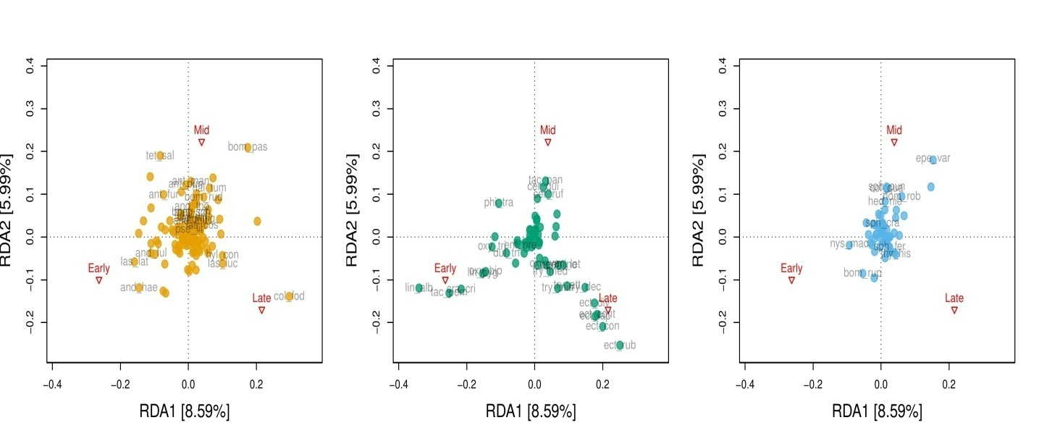

**Fig. 4. Plot of redundancy analysis (RDA) ordination for stage of succession as a discrete explanatory variable. For better visualization, the points are marked separately for individual trophic groups.**

*3*.*4 Changes in ß-diversity in the course of successional transformations*

Species turnover rate (the balanced component of ß-diversity) for herbivorous aculeates was stable (lack of significant differences between stages I and II and between II and III), but differed for predators and kleptoparasites. For predators, species turnover rate increased, whereas for kleptoparasites it decreased (Table 2, Fig. 5, Table A5). In contrast, changes in dominance structure (gradient component) were small and similar for all the three groups of Aculeata (Fig. A3).

**Table 2.** Estimated means and 95% confidence intervals (CIs) for beta generalized linear models (GLMs) of species turnover rates for the analysed successional stages and different trophic groups of Aculeata.

|  |  |  |  |  |  |
| --- | --- | --- | --- | --- | --- |
| Component | Group | Prediction | Lower 95% CL | Upper 95% CL | Stages |
| Balanced | Herbivores | 0.576 | 0.502 | 0.647 | I vs II |
| 0.544 | 0.470 | 0.616 | II vs III |
| Kleptoparasites | 0.719 | 0.655 | 0.776 | I vs II |
| 0.620 | 0.548 | 0.687 | II vs III |
| Predators | 0.619 | 0.547 | 0.687 | I vs II |
| 0.677 | 0.609 | 0.739 | II vs III |
| Gradient | Herbivores | 0.034 | 0.025 | 0.047 | I vs II |
| 0.036 | 0.026 | 0.050 | II vs III |
| Kleptoparasites | 0.036 | 0.026 | 0.049 | I vs II |
| 0.035 | 0.025 | 0.047 | II vs III |
| Predators | 0.037 | 0.027 | 0.051 | I vs II |
| 0.037 | 0.027 | 0.051 | II vs III |
| Bray-Curtis | Herbivores | 0.608 | 0.535 | 0.677 | I vs II |
| 0.575 | 0.502 | 0.646 | II vs III |
| Kleptoparasites | 0.754 | 0.694 | 0.806 | I vs II |
| 0.658 | 0.588 | 0.721 | II vs III |
| Predators | 0.659 | 0.589 | 0.723 | I vs II |
| 0.715 | 0.650 | 0.772 | II vs III |

CL = confidence limit

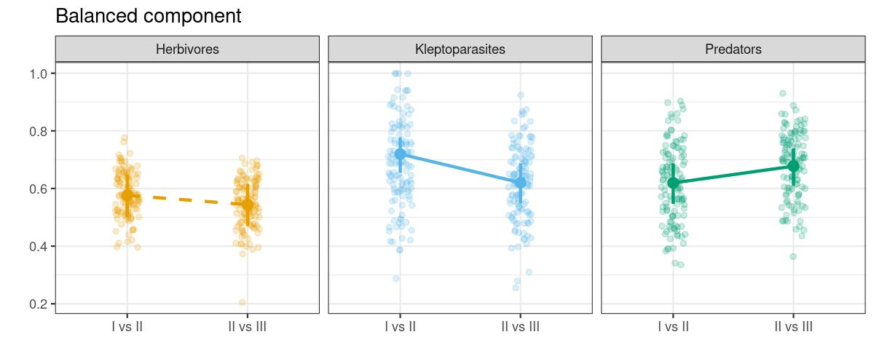**Fig. 5.** Means and 95% confidence intervals (CIs) for the balanced component of ß-diversity for the three trophic Aculeata groups at two transitional stages: I vs II and II vs III. Solid lines indicate statistical significance of the mean differences at ***α =* 0.05**. Points indicate empirical values.

*3*.*5*. *Species characteristic of individual stages of succession*

We identified 41 indicator species, including 15 herbivores, 21 predators, and 5 kleptoparasites (Table 3). Most of indicator species were characteristic of the middle stage of succession (17 species), compared to 10 in the early stage and 14 in the late stage. In the middle stage, herbivorous species prevailed (58.8%),whereas predators dominated in the early and late stages (80.0% and 71.4%, respectively) (Table 3). We evaluated the original 3x3 contingency table of 41 indicator species and found significant relations between successional stage and trophic group (*G*2 = 15.453, df = 4, *p* = 0.004). Herbivorous and kleptoparasitic species had similar patterns of characteristic species throughout the successional stages, with the highest proportion of indicator species in the middle stage (*G*2 = 1.243, df = 2, *p* = 0.537). In contrast, for predators the proportion of indicator species was significantly higher in the early (*G*2 = 4.640, df = 1, *p* = 0.031) and late successional stages (*G*2 = 9.569, df = 1, *p* = 0.002).

**Table 3.** Associations of individual species of Aculeata with successional stages: I = early; II = middle; and III = late.

|  |  |  |  |  |
| --- | --- | --- | --- | --- |
| Stage | Aculeata | Species | *IndVal* | *p* |
| I | Predator | *Crabro cribrarius* | 0.77 | < 0.001 |
| Predator | *Tachysphex pompiliformis* | 0.76 | < 0.001 |
| Predator | *Oxybelus bipunctatus* | 0.66 | < 0.001 |
| Predator | *Lindenius pygmaeus* | 0.63 | 0.001 |
| Predator | *Lindenius albilabris* | 0.62 | 0.016 |
| Herbivore | *Andrena haemorrhoa* | 0.56 | 0.004 |
| Predator | *Oxybelus trispinosus* | 0.47 | 0.011 |
| Herbivore | *Andrena fulva* | 0.41 | 0.031 |
| Predator | *Diodontus tristis* | 0.40 | 0.011 |
| Predator | *Entomognathus brevis* | 0.30 | 0.048 |
| II | Kleptoparasite | *Epeolus variegatus* | 0.65 | < 0.001 |
| Herbivore | *Bombus pascuorum* | 0.60 | < 0.001 |
| Herbivore | *Tetraloniella salicariae* | 0.57 | 0.031 |
| Predator | *Cerceris quinquefasciata* | 0.52 | 0.018 |
| Herbivore | *Andrena dorsata* | 0.51 | 0.028 |
| Kleptoparasite | *Sphecodes puncticeps* | 0.50 | 0.002 |
| Kleptoparasite | *Hedychrumniemeali* | 0.50 | 0.001 |
| Herbivore | *Megachile maritima* | 0.50 | 0.038 |
| Predator | *Tachytespanzeri* | 0.48 | 0.004 |
| Herbivore | *Anthidium punctatum* | 0.47 | 0.015 |
| Herbivore | *Bombus ruderarius* | 0.47 | 0.047 |
| Herbivore | *Halictus tumulorum* | 0.46 | 0.039 |
| Herbivore | *Anthophora furcata* | 0.43 | 0.032 |
| Herbivore | *Andrena thoracica* | 0.42 | 0.007 |
| Predator | *Cercerisruficornis* | 0.40 | 0.019 |
| Herbivore | *Anthidium manicatum* | 0.40 | 0.016 |
| Kleptoparasite | *Coelioxys quadridentata* | 0.33 | 0.028 |
| III | Predator | *Ectemnius rubicola* | 0.88 | < 0.001 |
| Predator | *Ectemnius confinis* | 0.88 | < 0.001 |
| Predator | *Ectemnius dives* | 0.78 | < 0.001 |
| Predator | *Ectemnius continuus* | 0.72 | < 0.001 |
| Predator | *Trypoxylon deceptorium* | 0.70 | < 0.001 |
| Predator | *Ectemnius lapidarius* | 0.68 | < 0.001 |
| Predator | *Trypoxylon attenuatum* | 0.56 | 0.003 |
| Predator | *Pemphredon lethifer* | 0.54 | 0.002 |
| Predator | *Trypoxylon minus* | 0.52 | 0.006 |
| Herbivore | *Colletes fodiens* | 0.51 | 0.037 |
| Predator | *Pemphredon inornatus* | 0.50 | 0.002 |
| Herbivore | *Lasioglossum lucidulum* | 0.39 | 0.027 |
| Herbivore | *Hylaeus confusus* | 0.36 | 0.027 |
| Kleptoparasite | *Thyreushistrionicus* | 0.30 | 0.046 |

Only statistically significant indicator values are shown (*IndVal* > 0.25).

*3*.*6*. *Rare and threatened species at individual stages of succession*

Rare and threatened species jointly accounted for 20.22%. This concerned mostly herbivores (19.29% of the group), and kleptoparasites (23.81% of the group). For the cumulated Aculeata community and for herbivores, probability of recording rare and threatened species was the highest in stage II (Fig. A4). For predators, probability values were the highest in stages II and III. For kleptoparasites, no significant differences between stages in this respect were found (Table 4, Fig. 6).

**Table 4.** Parameter values for the binomial generalized linear models (GLM) evaluating the proportion of individuals belonging to rare and endangered species at different successional stages and depending on Aculeata trophic group. Successional stages: I = early; II = middle; and III = late.

|  |  |  |  |  |  |  |
| --- | --- | --- | --- | --- | --- | --- |
| Stage | Group | Proportion | *N* | SE | Lower 95% CL | Upper 95% CL |
| I | Herbivores | 0.074 | 1275 | 0.007 | 0.059 | 0.088 |
| II | 0.109 | 1478 | 0.006 | 0.097 | 0.120 |
| III | 0.054 | 2822 | 0.006 | 0.042 | 0.065 |
| I | Kleptoparasites | 0.075 | 174 | 0.020 | 0.033 | 0.111 |
| II | 0.085 | 272 | 0.011 | 0.061 | 0.105 |
| III | 0.114 | 615 | 0.019 | 0.075 | 0.151 |
| I | Predators | 0.045 | 489 | 0.009 | 0.026 | 0.062 |
| II | 0.142 | 541 | 0.015 | 0.112 | 0.170 |
| III | 0.161 | 564 | 0.016 | 0.129 | 0.191 |

CL = confidence limit

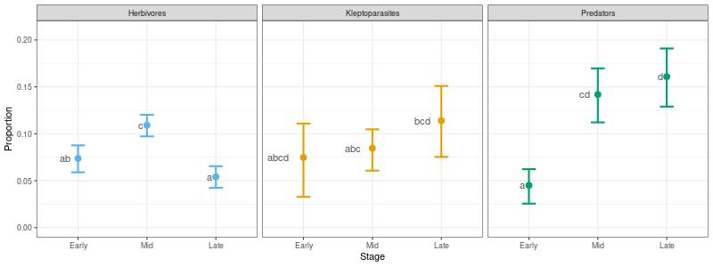**Fig. 6.** Proportion of rare and/or threatened species in the Aculeata community for different trophic groups at different stages of succession. Dots and whiskers represent predicted mean values and 95% CIs, respectively. Latin letters represent statistical significance at ***α =* 0.05,** adjusted for multiplicity (Tukey correction).

**4. Discussion**

Results of this study confirm that occasionally used sand quarries, gradually colonized by plants, are important habitats for various groups of the Aculeata, differing in life history (Apiformes, Spheciformes, and Chrysididae). The significance of spontaneously overgrown extraction sites for biodiversity preservation was reported earlier also by other researchers (Tropek et al., 2010; Řehounková et al., 2011; Prach et al., 2013). However, such habitats are subject to dynamic processes of ecological succession, which markedly influence their value for biodiversity preservation. The high conservation potential of such sites is confirmed by the fact that about 20% of the species recorded there are rare or threatened. We found that the appearance of new species, rather than changes in their dominance structure, significantly affected species exchange in communities of all the three groups of Aculeata. This significantly affected the occurrence of rare and threatened species, and – as a consequence – also the conservation value of the studied habitats. If we take into account the cumulated Aculeata community, the value decreased at early stages of succession. However, the character of these changes depends on the considered trophic group.

In our study, the Aculeata community reached the highest complexity level at the middle stage of succession. The sites at the late stage of succession were characterized by the lowest values of the analysed indices. This pattern was primarily due to a significant increase in abundance and species richness of herbivores and parasites. This is consistent with observations made by other researchers (Steffan-Dewenter and Tscharntke, 2001; Potts et al., 2003; Rutgers-Kelly and Richards, 2013), who found that the richness of Apiformes is proportional to bee food resources and tends to increase in the first years of successional transformations, but later it declines. Undoubtedly, the availability of bee forage plants and presence of suitable nesting sites are factors determining bee occurrence in the environment (Ricketts et al., 2008; Ritchie and Johnson, 2009). In the case of herbivores, this can be associated with modification of habitat structure, linked with colonization of the substrate at the first stage of succession and appearance of new bee food plant species. The major reasons for the decline of bee diversity in wooded habitats include simplification of vegetation structure, loss of food resources, and disappearance of suitable nesting sites (Winfree et al., 2007). The studied sites were covered mostly with synanthropic vegetation, also ruderal species, which attests to a high level of human impact (Twerd et al., 2019a). Such species often colonize transformed and degraded sites (Kuzmič and Šilic, 2017). Another important factor is the rate of succession, depending on substrate type. Succession on poor, dry, and sandy soils is slow, whereas on fertile and moist soils, its rate is much faster (Ejrnaes et al., 2003). In the case of our research, the rate of species turnover for herbivores seemed to remain constant throughout successional stages, with a higher proportion of rare species in the middle stage of succession. This pattern was possibly due to highly specialized oligolectic bees, usually associated with ruderal plant species, which dominated at the sites in the middle stage of succession (Twerd et al., 2019a). In the case of kleptoparasitic communities, their species turnover was found to slow down in the course of succession but followed possibly the patterns of their hosts (i.e. mainly wild bees). In the case of predators, we did not detect any changes in values of community indices. We found, however, that changes in community structure of predators accelerated at the later stages of succession, and this was mainly driven by rapid accumulation of new and rare species. This resulted from simultaneous presence of species preferring open habitats, e.g. *Cerceris arenaria* (L., 1758), *Lindenius albilabris* (F., 1793), *Philanthus triangulum* (F., 1775), as well as stenotopic species associated with wooded habitats, e.g. *Ectemius continuus* (F., 1804) and *E. rubicola* (Dufour and Perris, 1840). Many of them are rare and threatened with extinction in Poland, e.g. *Bembecinus tridens* (F., 1781), *Harpactus laevis* (Lat., 1792), *Lestica alata* (Panzer, 1797). A similar relationship was observed during research on attractiveness of another type of anthropogenic habitats, i.e. Solvay process waste beds, rich in calcium (Twerd et al., 2017). The cited study showed that the most favourable stage of succession in the waste beds was their colonization by woody vegetation, as the bee community included then species characteristic of open habitats as well as stenotopic species associated with wooded habitats (Twerd et al., 2017). In the present study, this was possible because the analysed sand quarries are exploited only periodically. Because of the small scale of exploitation of the sand quarries, they are subject to spontaneous succession. As a result, various microhabitats are formed within them, including both bare sandy soil and areas colonized by vegetation, including forest communities. Besides, in some of the sand quarries, exploitation was stopped about the year 2006. The sites were not rehabilitated and were only subject to spontaneous succession. At present, they are dominated by *Pinus sylvestris.* In this case (late stage of succession), the proportion of herbaceous vegetation reached 15–40%, while woody vegetation exceeded 60%. Anyway, in most such sand quarries, part of deposits remained uncovered. This was due to the fact that when industrial exploitation was stopped, the local inhabitants often started to use them illegally, which does not allow their complete colonization by plants. However, this creates conditions for coexistence of species with different habitat preferences, and thus increases the conservation value of these sites (Kerbiriou et al., 2018).

Communities of herbivores, in contrast to kleptoparasites and predators, greatly differed between the stages of succession and our results may indicate a significant role of random factors conditioning their variability (Ponisio et al., 2017). On the other hand, in contrast to our expectations, predator communities maintained some degree of structural coherence, in spite of the faster species turnover rate. This is reflected in a relatively high number of persistent species, present in all stages of succession. This suggests that these species might be keystone species in trophic networks (Piraino et al., 2002). From the conservation standpoint, special attention is paid to rare and threatened species. However, they do not necessarily perform an important function in ecosystems, and their increased contribution to the community can be due to habitat size (Krauss et al., 2009) and proximity of natural habitats (Novák and Konvička, 2006). The role of rare species in the communities is still unclear, but our study assessed changes taking place in Aculeata communities and suggests that overall variability of communities should be taken into account, with numbers of rare and threatened species, to determine protection priorities.

**6. Conclusions**

Spontaneously colonized sand quarries can play an important, trans-regional role in nature conservation, as favourable sites for rare insect species and as substitute habitats for species threatened with extinction in Europe. However, their protective value for individual taxa and groups differing in life history varies widely. That is why a multi-taxon approach is needed for development of management plans for such sites. The problem of simultaneous protection of species with different ecological requirements can be solved by allowing spontaneous succession in abandoned mines. Because of species substitution, which takes place during natural succession, active protection measures must be implemented, too. Such measures should aim at maintenance of a mosaic of habitat sat various stages of successional transformations.

## **Acknowledgments**

This work was supported by the Polish Minister of Science and Higher Education, within the program “Regional Initiative of Excellence” in 2019-2022 [Grant No. 008/RID/2018/19].

**References**

**Fig. 1.** Location of study sites (sand quarries).

**Fig. 2.** Representative photographs of stages of plant succession in sand quarries: a, b = early succession; c, d = middle succession; e, f = late succession.

**Fig. 3. Diversity, abundance, and species richness of Aculeata at the three distinguished stages of succession. Abundance was subjected to logarithmic transformation, to visualize better the differences between groups. Transparent points denote empirical values. Latin letters represent**statistical significance at ***α =* 0.05, adjusted for multiplicity (Tukey correction).**

**Fig. 4. Plot of redundancy analysis (RDA) ordination for stage of succession as a discrete explanatory variable. For better visualization, the points are marked separately for individual trophic groups.**

**Fig. 5.** Means and 95% confidence intervals (CIs) for the balanced component of ß-diversity for the three trophic Aculeata groups at two transitional stages: I vs II and II vs III. Solid lines indicate statistical significance of the mean differences at ***α =* 0.05**. Points indicate empirical values.

**Fig. 6.** Proportion of rare and/or threatened species in the Aculeata community for different trophic groups at different stages of succession. Dots and whiskers represent predicted mean values and 95% CIs, respectively. Latin letters represent statistical significance at ***α =* 0.05,** adjusted for multiplicity (Tukey correction).

**Table 1.** Mean values and their asymptotic 95% CIs for linear and generalized linear models for diversity (Shannon index), abundance, and species richness of three Aculeata trophic groups at three studied successional stages. Different Latin letters in the last column correspond to statistically significant differences (Tukey correction for multiplicity, ***α*** > 0.05). Successional stages: I = early; II = middle; III = late.

**Table 2.** Estimated means and 95% confidence intervals (CIs) for beta generalized linear models (GLMs) of species turnover rates for the analysed successional stages and different trophic groups of Aculeata.

**Table 3.** Associations of individual species of Aculeata with successional stages: I = early; II = middle; and III = late.

**Table 4.** Parameter values for the binomial generalized linear models (GLM) evaluating the proportion of individuals belonging to rare and endangered species at different successional stages and depending on Aculeata trophic group. Successional stages: I = early; II = middle; and III = late.